 [Translated from German to English - www.onlinedoctranslator.com](https://www.onlinedoctranslator.com/en/?utm_source=onlinedoctranslator&utm_medium=docx&utm_campaign=attribution)

**1 Mechanics**

Handling device technical documentation

by Dr.-Ing. Paul Christian' GmbH & Co. KG 5

**1.1 Functional description**

The handling device can be used to perform so-called "pick-and-place" tasks. Workpieces are picked up from one location and placed at another.

This three-axis handling device covers a working range of 200°. Within this working range, any number of positions can be reached.

The X-axis is driven by a DC motor with an integrated rotary encoder, which can be controlled by the associated evaluation electronics and a PLC.­

The left or right rotation of the drive is realized with a reversing contactor circuit.

A non-rotating double-acting pneumatic cylinder with a stroke of 60 mm moves the "Y-axis" up and down.

The "Z-axis" is moved by a non-rotating double-acting pneumatic cylinder with a stroke of 100 mm.­

The handling device is equipped with a vacuum suction device to hold the workpieces.

The functional module is completely constructed on two mounting platforms and can be flexibly mounted individually or together with other functional modules on an aluminum profile plate.

The supply voltage for the functional module is 24 VDC and is established via a 10-pin connecting cable. The air supply is via a 4 mm air connection (plug-in coupling), and the operating pressure is 4 bar.

A DC motor with gearbox and rotary encoder, a reversing contactor circuit, an inductive proximity switch, several reed switches, solenoid valves and a venturi nozzle are available for operation.

The connection to a controller is established via two 8-bit transfer connectors. For complete control of the functional module, seven digital inputs and five digital outputs should be available on the PLC.­

Two of these inputs must be fast counter inputs in order to be able to evaluate the encoder signal.­

**Danger!**

Never move the arm of the handling device by hand while the motor is connected. This may damage the motor or encoder electronics.

**The handling device is intended to perform the following tasks in conjunction with other mechatronic functional modules:­**

**Technical documentation handling device**

**6 by Paul Christiani GmbH & Co. KG**

**To pick up workpieces from a conveyor belt and feed them to a press for further processing.­**

**To pick up workpieces from a conveyor belt and place them in a pin station via a turning station in order to transport the workpiece to a press for further processing after the pinning process.**

**Picking up workpieces from a conveyor belt and transferring them to a high rack for storage.**

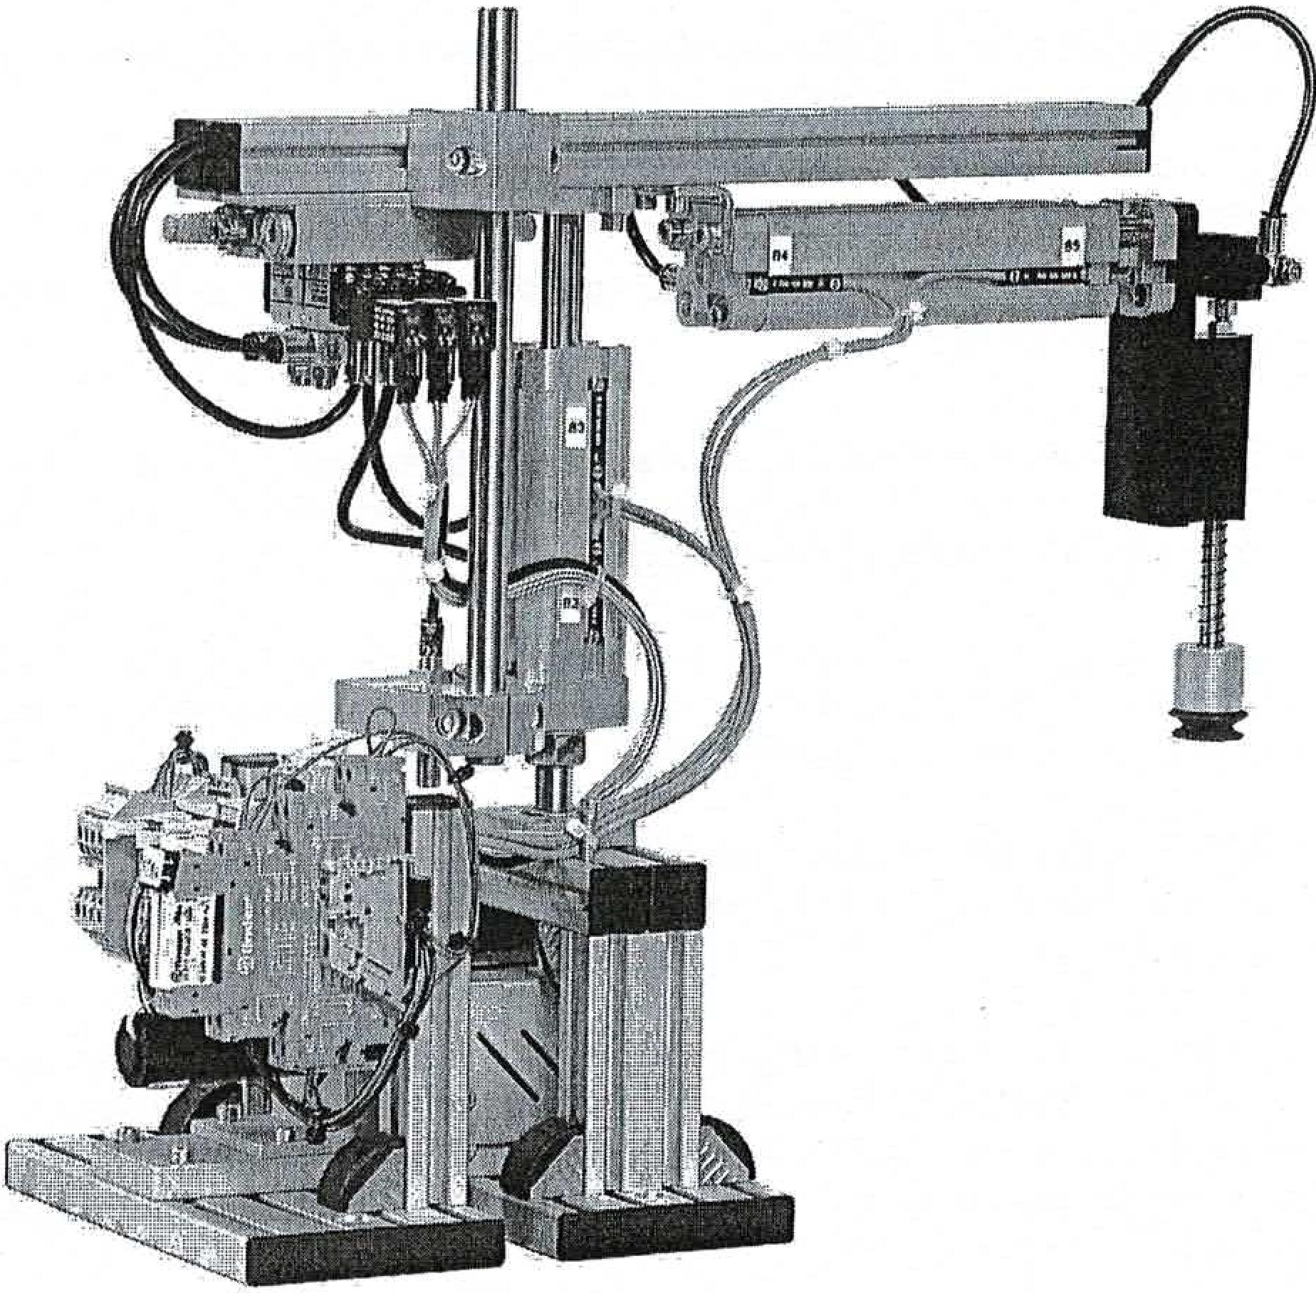

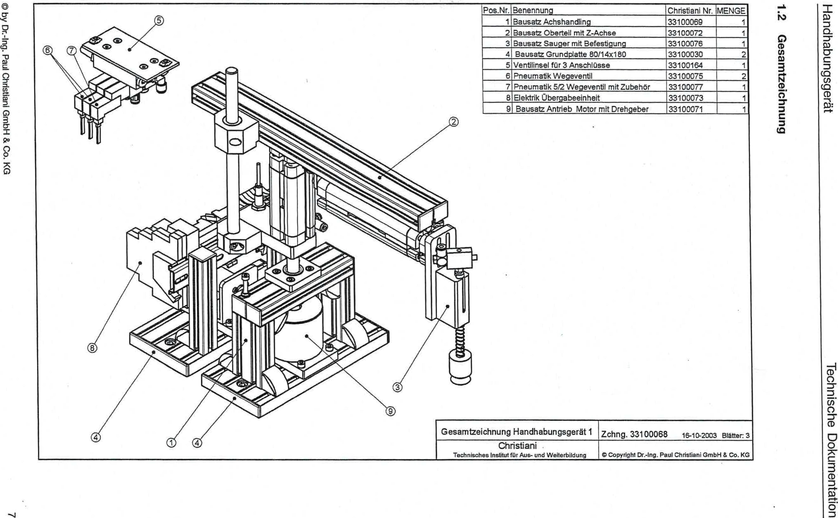

0 by Dr.-Ing. Paul Christiani GmbH & Co. KG

**6unuippziwese9**

m)96sbunqet_ipuuki

tiogiuownloo eLiosptpai

|  |  |  |  |  |
| --- | --- | --- | --- | --- |
| Item No. | designation | Christiani No. iMENGE | | |
| 1 | Axle handling kit | 33100069 |  | 1 |
| 2, | Construction saw upper part with Z-axis | 33100072 |  | 1 |
| 3 | Suction cup kit with attachment | 33100076 |  | 1 |
| 4 | Base plate kit 80/14x180 | 33100030 |  | 2 |
| 5 | Valve island for 3 connections | 33100164 |  | 1 |
| 6 | Pneumatic VVege valve | 133100075  1 |  | 2 |
| 7 | Pneumatic 5/2 V-valve with accessories | 133100077 |  | 1 |
| 8 | Electrical transfer unit | 33100073 |  | 1 |
| 9 | Kit drive motor with encoder | 33100071 |  | 1 |

General drawing of handling device 1

Drawing 33100068 16-10-2003 Pages: 3

Christiani

Technical Institute for Education and Training

eCopyright Dr.-Ing. Paul Christiani GmbH & Co. KG